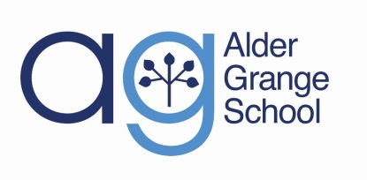
Draft GCSE Results 2018

Performance Indicator | Percentage of Pupils
 | 2015 | 2016 | 2017 | 2018
Progress 8 Score |  | -0.39 | -0.49
Attainment 8 Score |  | 47.58 | 41.2 | 41.8
% Achieving a standard pass in English and Maths |  | 65% | 66% | 59%
% of students who continue in education or training, or move on to employment at the end of 16 to 19 study. |  | 95% | 97%
5+ A*-C (E M) | 47% | 58% | 59% | 54%
3+ Levels Progress English | 57% | 59%
English Baccalaureate | 10% | 14% | 11% | 2%
3+ Levels Progress Maths | 72% | 75%
4+ Levels Progress English | 15% | 18%
4+ Levels Progress Maths | 39% | 34%
English C+ | 53% | 69%
Maths C+ | 70% | 79%
English 4+ |  |  | 70% | 70%
Maths 4 + |  |  | 74% | 70%

